SQL Assignment

Create Database



Create Table

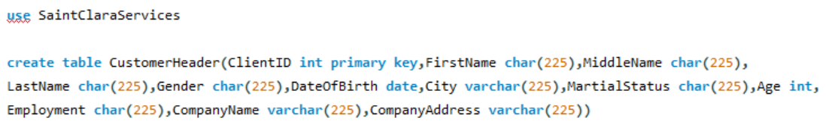

Employment Char TO Varchar

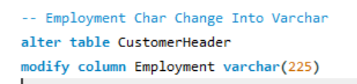

Add Qualification Char

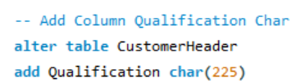

Drop Middle Name

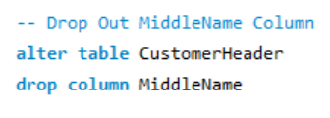

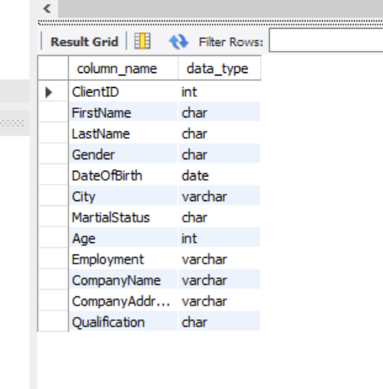

Data Insertion

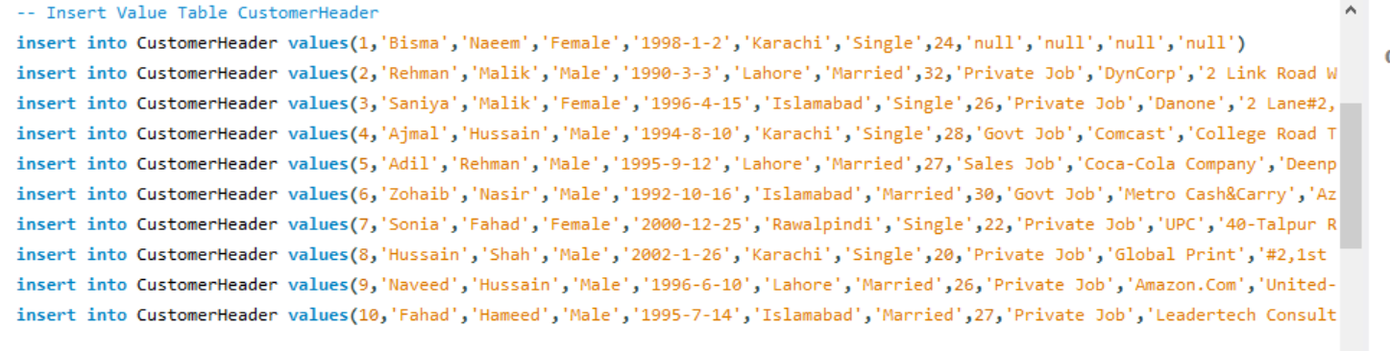

OutPut

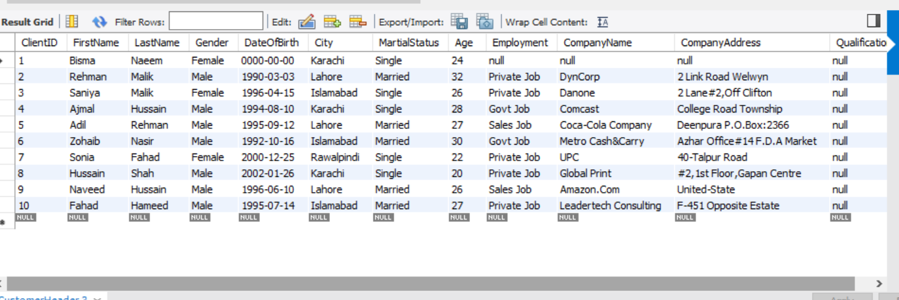

Second Table

Create Table



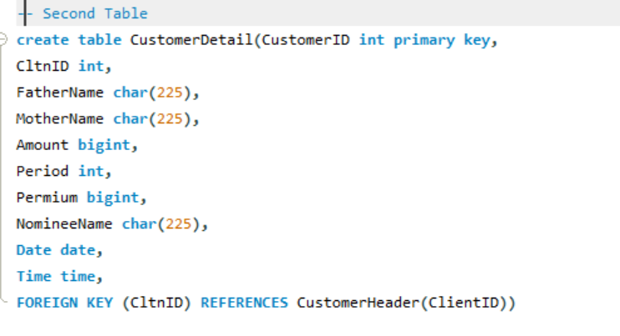

Updating Column

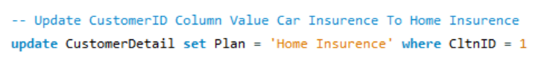



Alter Column Period Int To Bigint

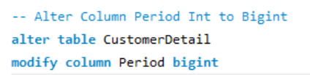

Add Column Plan Varchar

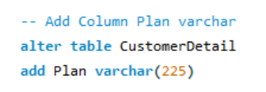

Drop Out Time Column

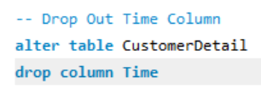

Show Data Type



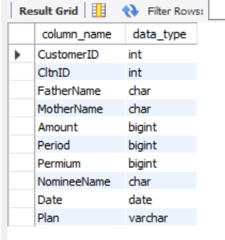

Data Insertion

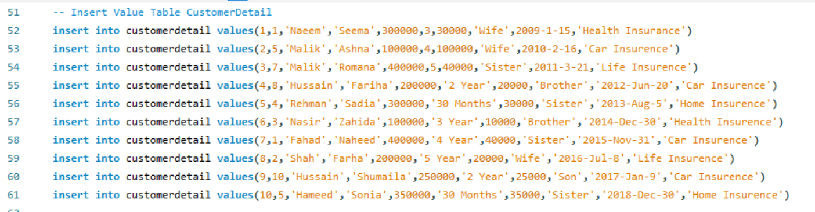

OutPut

